35.49: For this film on this glass, there is a net 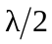 phase change due to reflection and the condition for destructive interference is 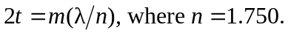
Smallest nonzero thickness is given by 